To: Dr. Sarah Oman & Ulises Fuentes
From: Kadeja Alhossaini, Nathan Firor, Edwin Smith, & Ethan Vieane
Date: 03, April 2020
Subject: Implementation Memo II

The purpose of this project is to create a braze welding jig for a company called SunTrac USA which is located in Tempe, Arizona. SunTrac manufactures radiant solar panels that when coupled with variable speed or two speed Air Conditioning systems reduces the energy consumption of the AC system by up to 45 %. The most important component of these solar panels is a copper manifold that must be brazed on both ends and comes in three different sizes, 4 feet, 6 feet, and 8 feet. SunTrac has two jigs in their possession, however they would like to have one jig that can change to fit all three sizes. Our capstone team has been tasked to create a design for SunTrac that fits the company’s requirements and can accurately achieve the company goal. Due to the current COVID-19 virus outbreak, the team could not complete the manufacturing process in its entirety. The manufacturing and design changes that were completed before the outbreak will be discussed in detail in this memo. In addition to the design changes, the standards and regulations that went into the manufacturing process discussed as well as the risk analysis and mitigation.

Implementation – Weeks 7-11
Over the previous several weeks, many of the set benchmarks detailed in implementation memo one have been accomplished. This included purchasing the parts detailed on the bill of materials and having them shipped to the SunTrac facility. Once all the parts were shipped to SunTrac’s manufacturing facility, they were cut to size and assembled as shown in the completed CAD package. 90% of the project is completed with an additional 10% delayed due to implemented regulations by SunTrac to combat the COVID-19 crisis. These updates have been accomplished over three consecutive Fridays and Saturdays from 3/6 to 3/21. During the manufacturing of the jig, multiple changes were made that primarily increased the rigidity and structural integrity of the jig frame. The other subsystems were largely unchanged from the last report.

Manufacturing
Since the design consists solely of steel parts, power tools were a necessity in cutting, drilling, grinding, and welding the jig together. SunTrac’s manufacturing facility had all the needed tools in order to be successful in this project. The first step in the manufacturing process was to measure the parts with a measuring tape and marked with soapstone. Calipers were used for cuts requiring higher precision and then a punch would mark holes for drilling and tapping. Ample use of WD-40 was used dually for lubrication and cooling of the cutting blades and drill bits. Balances and angle gauges were there to measure out and then check our work.

The larger tools include a bandsaw, chop saw, angle grinder, drill, and 110V ARC welder. The bandsaw was used to make precise straight cuts in the steel. A chop saw and a portable band saw aided in making angled cuts; particularly the frame is composed of many angled cuts. Any cuts that were made were filed down with an electric angle grinder or simple file. A drill press was utilized for making accurately placed holes for the telescoping tubes and locking assembly. A handheld drill was more feasible for making holes in the frame as some were angled. The welding was the only portion that the team did not do as that was left to a SunTrac employee and their personal arc welder.
All calculations were conducted by using the detailed CAD package to measure segments virtually and making adjustments to our physical parts. This method ensured that the angles were cut accurately and complex parts would fit with the rest of the assembly. All other testing procedures require the jig to be completed and therefore must be postponed till business at SunTrac returns to normal. A detailed list of other testing procedures have already been written given to the SunTrac executive board.

1.2 Design Changes - Weeks 7- 11
The recent changes that were made to the design came from observable issues that arose during the manufacturing days at the Suntrac facility. These changes were mostly made upon speculation in hopes of mitigating future problems and reinforcing the overall structural integrity of the jig stand.

Design Iteration 1: Change in [Block Assembly]
Firstly, when designing the block assembly there were some concerns about interferencing with the bearing. We did not know how far the bolts would protrude from the back plate so in the CAD model, another inch and a half was left. During the assembly, more measurements were taken with the bolts present and it was found that the top and bottom weldments could be shortened. The shorter this is the better because a shorter length means there is less of a moment arm and less induced stresses on the interface between the locking assembly and the jig stand.
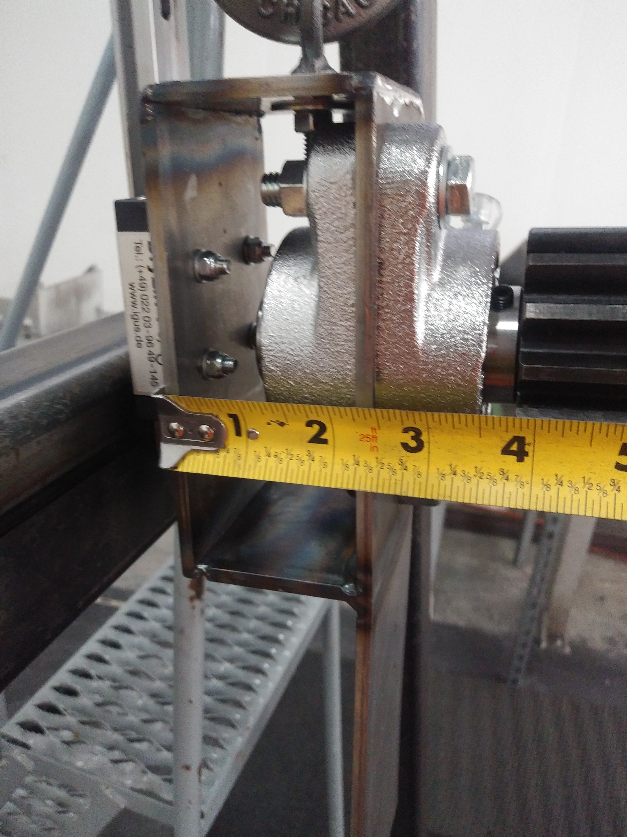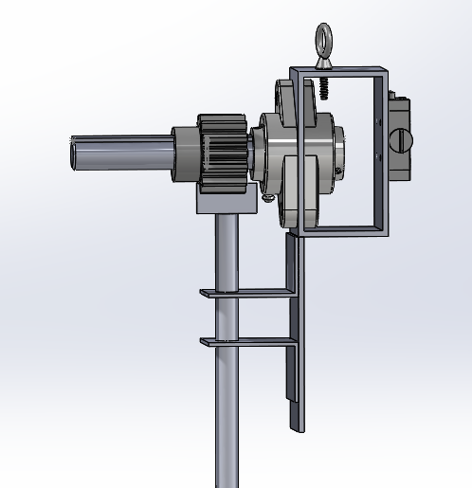
Figure 1: CAD Comparison to Shortened Block
As seen in figure one above, the clearance gap portrayed by the CAD model is 3 inches before it was shortened to two inches in the physical model.

Design Iteration 2: Change in [Guide Rail Subassembly]
An initial concern about the guide rail assembly became a problem once the physical model was built. Although the rail is rated for a high static load capacity, the team found that significant angular deflection occurred when the induced moment arm from the weight of the locking assembly and jig face was applied. To combat this, the support strut made from excess tubing was cut and welded behind the guide rail as well as the guide rail was secured with more bolts that are drilled through the new support. Since this modification used scrap metal from other cut pieces it did not cost any extra money from the teams budget.
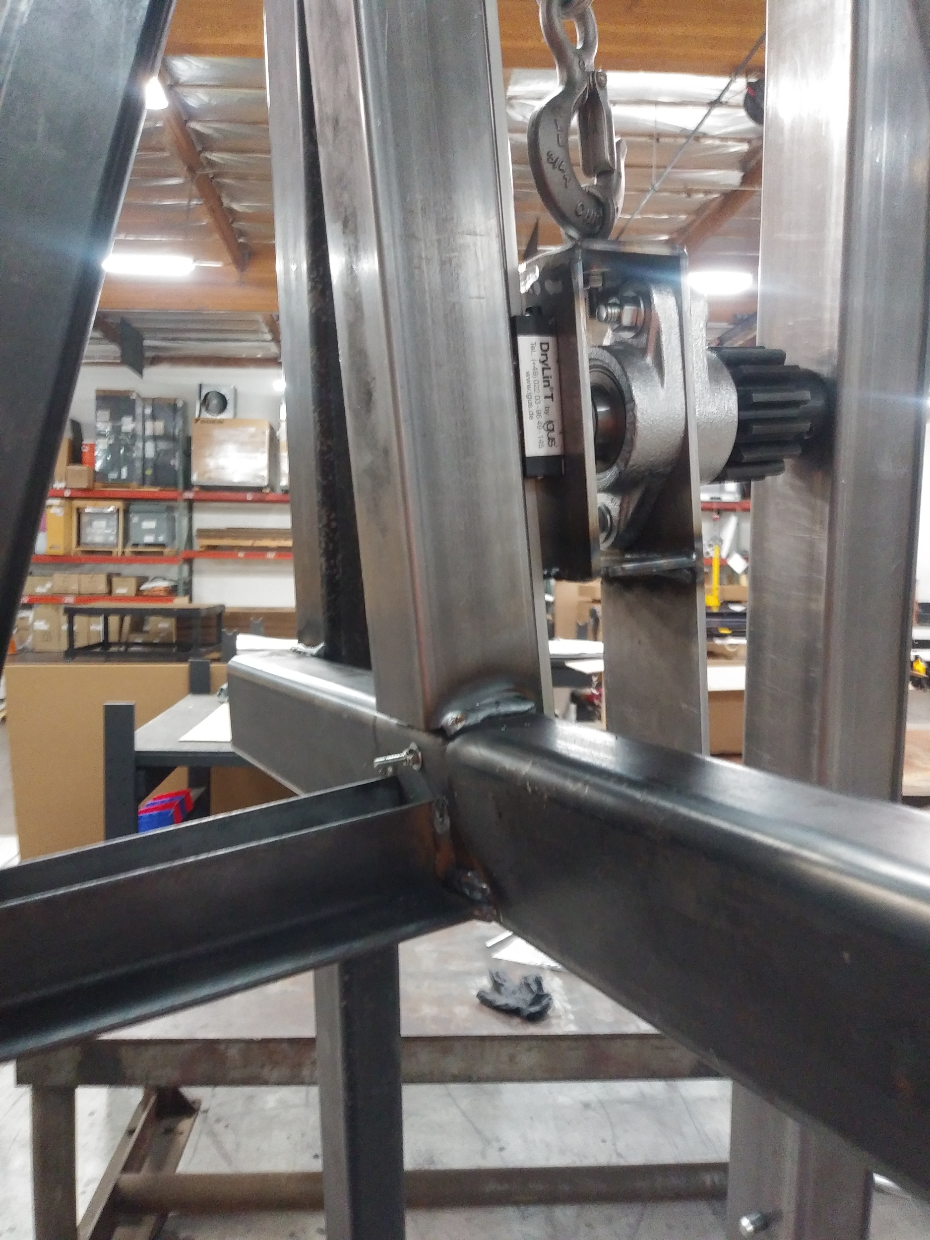
Figure 2: Guide Rail Support Augment
As seen in figure two above, there are welds at each end of this new support which drastically increased the strength and rigidity of the subassembly.

Design Iteration 3: Change in [Frame]
The support beam at the back of the a frame is critical to ensuring that the design does not fall. A SunTrac employee was concerned that a single weldment towards the top of the A-frame to keep this leg in place is not strong enough; and that it would certainly break when transporting. Excess angle iron that was used to create the standoffs was added to increase the structural integrity of the frame. This alteration was made from scrap and therefore did not add any cost to the BOM.
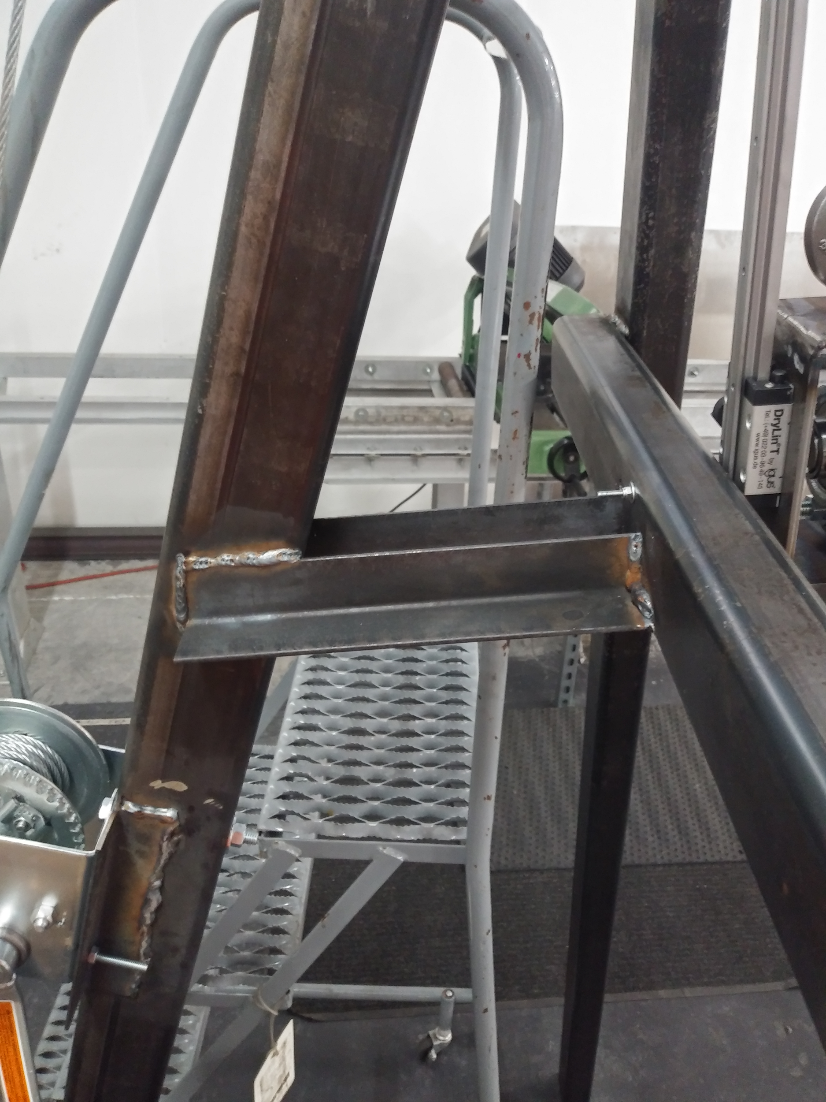
Figure 3: Frame Support Augments
Two individual pieces were cut and set on each side of the beam so that they were not in the way of the bolt that comes out of the frame in front.

Design Iteration 4: Change in [subsystem/component] discussion
A similar reinforcement was made to the winch. In order to comply with OSHA and other safety standards, the winch model was changed to one designed for lifting applications. It being a different winch, the locations of the mounting holes changed and needed a wider area to be mounted to. Excess angle iron was used to increase this surface area. Holes for the bolts were drilled through this angle iron as shown in Figure four.
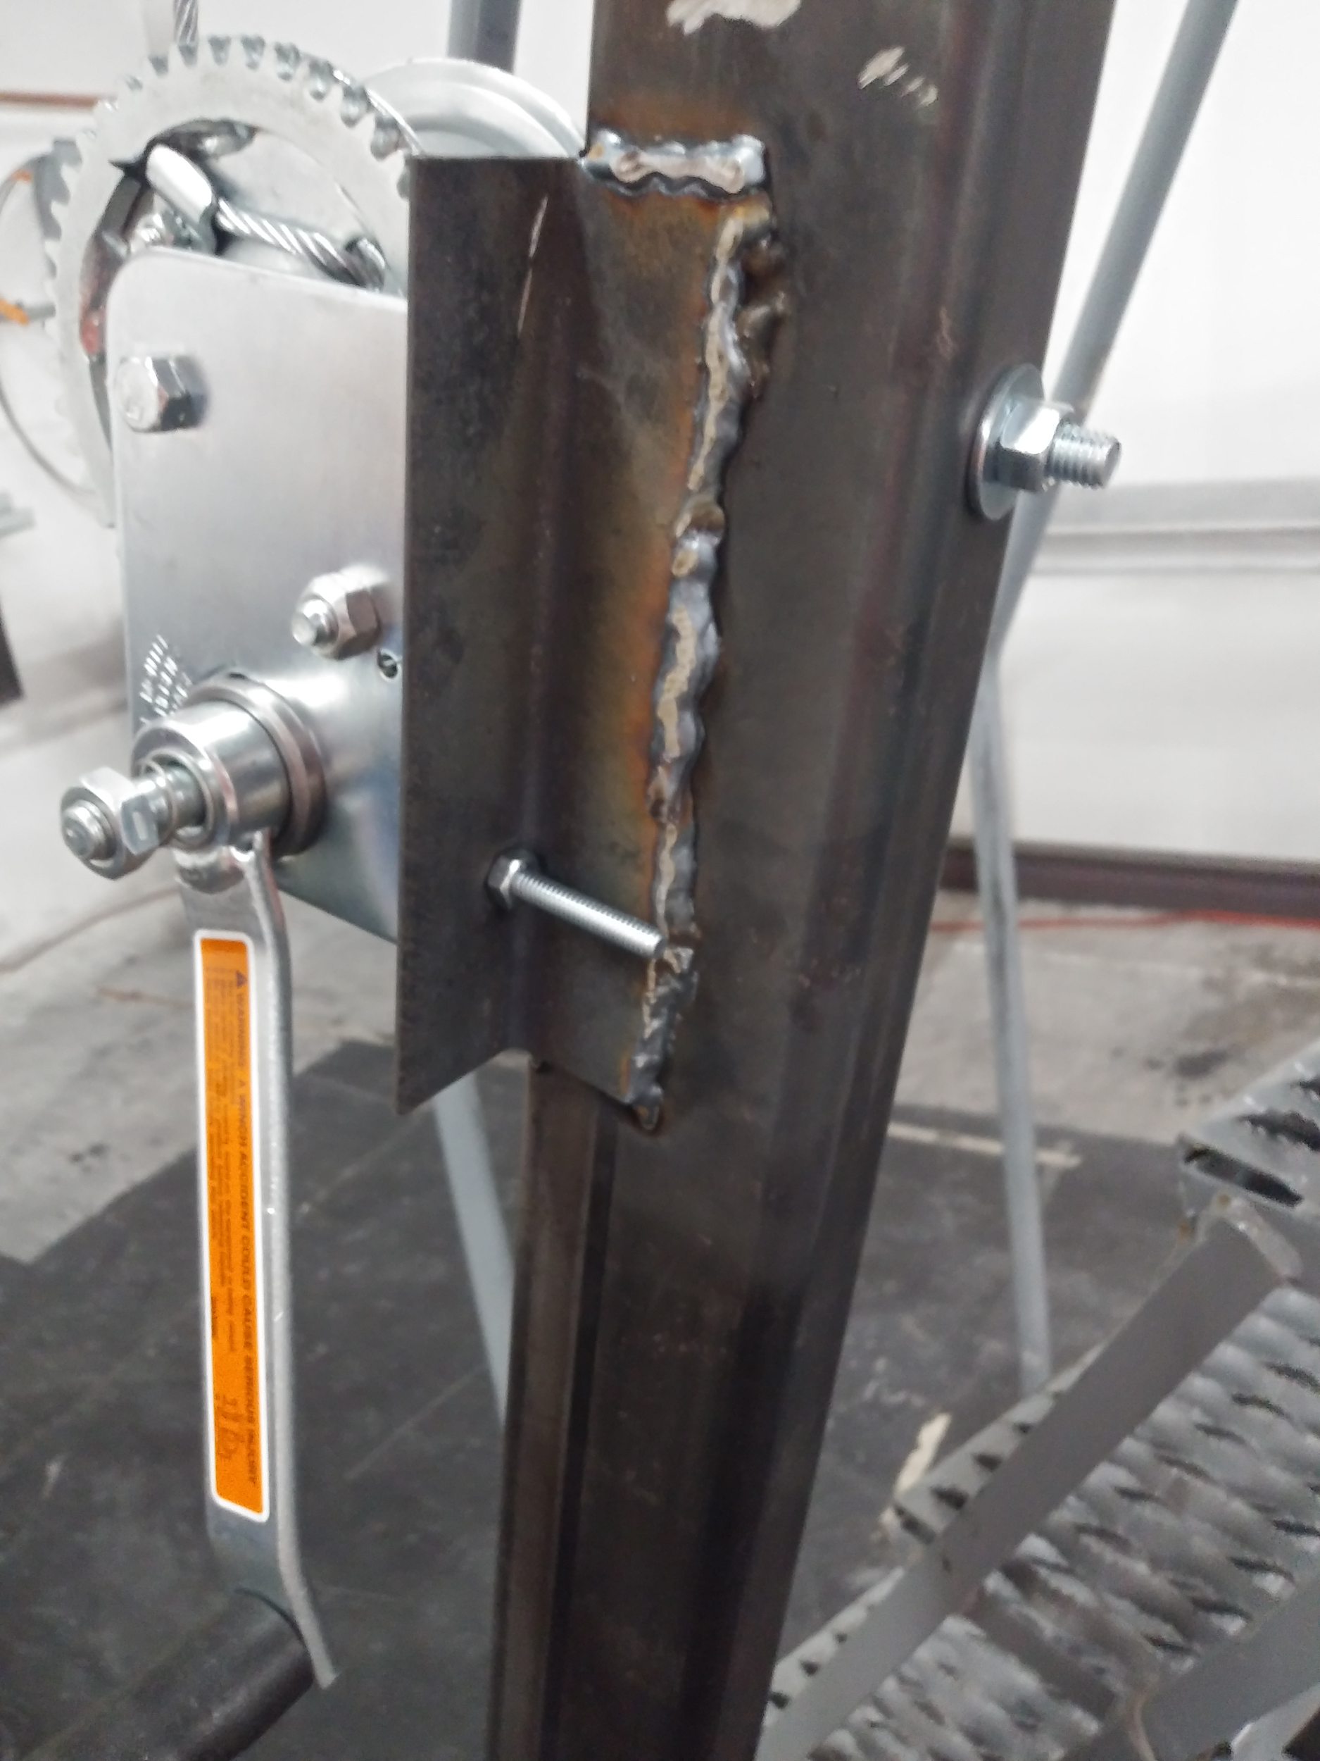
Figure 4: Angle Iron Winch Mount Augments
As seen, bolts on each side go through the mounts while the big main bolt goes through the beam. The length of the iron is approximately the length of the winch base so the weld bead could be strong.

Standards, Codes, and Regulations
In this project, the standards, codes, and regulations, were important factors to consider while manufacturing the system. SunTrac is a company that is recognized globally, therefore it is necessary to ensure the brazing jig complies to these standards. Since the system was not fully built due to the COVID-19 outbreak, some standards were not tested but they still factor in the manufacturing left to complete the final product and its testing. The table that is presented below lists the regulations and standards that impact the manufacturing and testing process. Details of how each standard applied to the project will also be discussed. The table will clearly show which standards are already achieved and the standards that would have been achieved if the manufacturing and testing process was completed. Most of the standards and regulations were already listed in the Final Proposal that was created last semester, but a few adjustments were made [ 1].

Standards applied to project
Table 1. Standards and Codes Applied to this Project
Standard Number or Code | Title of Standard | How it applied to Project
OSHA 1910.24 [2] | Occupational Safety and Health Standards | This standard was used to make sure the material of the bolts that were used in manufacturing are made up of a material that protects against corrosion, and the bolts are capable of supporting their maximum intended load.
ASTM  E3052-16 [3] | Standard Practice for Examination of Carbon Steel Welds Using Eddy Current Array | This standard would have been used to detect surface-breaking cracks on the joints of the jig where it is welded together.
ANSI/AGMA  1010-F14 [4] | Appearance of Gear Teeth- Terminology of Wear and Failure | This standard was used to predict the most common types of gear teeth failure which assisted us with choosing a gear with an appropriate number of teeth to be used in the locking mechanism.
ANSI/AGMA  2004-C08 [5] | Gear Materials, Heat Treatment and Processing Manual | This standard was used to choose an appropriate gear material with respect to the surrounding environment, weight limitations, and component geometry.
ASME  Y14.5 [6] | Dimensioning and Tolerancing | This standard was used when dimensioning and tolerancing in drawings, models and document files according to GD&T.
ASTM  A606/A606M [7] | Standard Specification for Steel, Sheet and Strip, High-Strength, Low-Alloy, Hot-Rolled and Cold-Rolled, with Improved Atmospheric Corrosion Resistance | This standard was used to choose Hot-Rolled Carbon Steel material for the frame of the welding jig.
ASTM  A489 [8] | Standard Specification for Carbon Steel Eyebolts | This standard was used in choosing an appropriate galvanized steel eye bolt that mounts the pulley onto the jig frame.

Risk Analysis and Mitigation
To analyze failure and risk, a Failure Modes and Effects Analysis (FMEA) has been conducted. The analysis consists evaluating risk of the components which five critical subsystems comprise of. The full FMEA is illustrated in appendix A, and consists of the FMEA procedure carried out for each part in the bill of materials while considering all failure modes combined for each part. For the analysis that will be discussed in this section, the failure modes for each part have been isolated and analyzed individually. The subsystems analysed in this process include the pivot mechanism about which the jig face rotates, the jif face, jig frame, locking mechanism, guide rail, as well as the sliding tubes which satisfy the variability engineering requirement. To quantify the effects of the failures of each subsystem component, a risk priority number is calculated. During this process many steps are carried out, these include: listing potential failures for each component, list the causes and effects of these failures, develop design control tests to detect failure before production, and provide recommended action. To calculate the risk priority number directly, three values must be generated all on a 1-10 scale. These values being Severity (S) based on how severe the failure is, Occurrence(O) based on how likely this failure is to occur in its application, and Detection (D) being how easily the defect will be detected. This process is outlined in the section below.

Potential Failures Identified Fall Semester
A shortened version of the FMEA has been conducted to illustrate in the report the top ten most considerable risks, that is the ten risks with the greatest risk priority number; this can be seen below in Table 2.

Table 2. Shortened FMEA
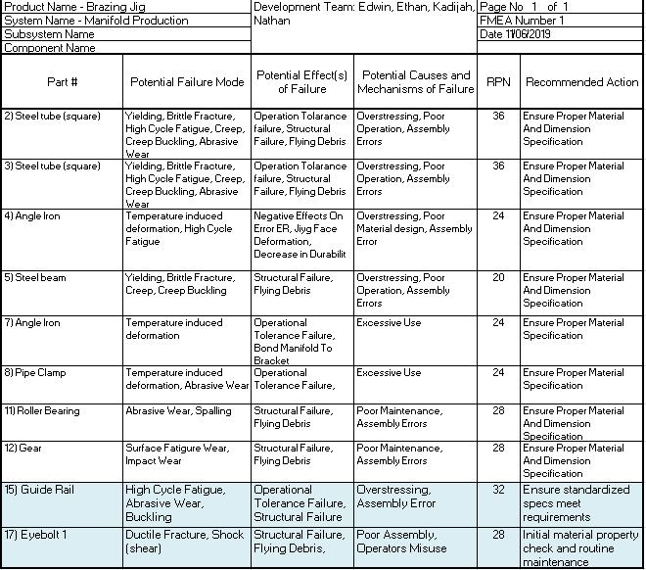

The revision from last semester Failure Modes and Effects Analysis includes adding risk information for five new parts that were not on the old Bill of Materials. Two of these five are within the top ten most considerable risks (highest risk priority number) and are highlighted in blue at the bottom of the shortened FMEA. The other three parts can be found in Appendix A.

As mentioned earlier in this memo, during the manufacturing process of the team prototype excess material was often used to create new structural supports and did not warrant its own part number. These parts are employed only to mitigate risk and aren’t justified in requiring their own risk analysis. The new risks that are considered in the updated FMEA are the hanging pulley, pulley eyebolt, locking mechanism eyebolt, guide rail, and carriage. The guide rail and pulley are the only two within the top ten most considerable risk with a RPN of 32 and 28 respectively as the severity of these components are significant. The guide rail and carriage are also important sub-systems, and have catastrophic failures, although the excess material supports have greatly mitigated risk across the guide rail and carriage specifically.

Risk Mitigation
The component with the greatest risk priority number is tied among the steel tubes. This is because the steel tubes are the most essential and multi-faceted component which holds the greatest tolerances, operate dynamically, and contain a lot of potential energy. These telescoping tubes are in and of itself the bulk of the entire prototype, and if they fail, the prototype fails. Although due to this reason the team has spent due time mitigating these risks. More than one entire manufacturing day was spent solely drilling the pin locations on the telescoping tubes to ensure that the spacing is of correct tolerance, this was achieved. The angle irons, which restrict movement from the vertical tubes during operation, while providing continual structural support to the telescoping tubes have been repositioned more towards the center of the tubes to mitigate effects of buckling. The guide rail is the next riskiest part with an RPN of 32. The heightened risk level for the guide rail differs slightly from the telescoping tubes in that there aren’t any risks associated with the guide rails potential energy, or the tolerancing associated with it, all of its risks revolve around its structural integrity. The resilience of this component is so important that an FEA analysis has been done on it. It was determined that the guide rail would surely experience risk during operation. Once the prototype became developed enough, this was physically tested and confirmed to be a serious issue. Extra 2x2 carbon steel had been laying around from a telescoping tube cut, this was then welded behind the guide rail and bolts then secured the guide rail to this new support beam, this is illustrated in [Fig. 2]. After this risk mitigated took place, deflection of the guide rail was then tested again and shown to withstand the greatest loads that it would experience during operation. Another critical part regarding risk is the pulley eyebolt. This eye bolt holds the pulley upright, which holds the locking mechanism, which in turn holds the weight of the entire jig face. If this component fails, it would risk serious injury to anyone nearby. To mitigate this risk two nuts were placed on top of two washers to account for extra stresses that may occur. This is the only action that took place for this risk as the eyebolt specifications met and surpassed the conditions it would experience during operation.
There isn’t much risk trade off for this project as the bulk of solutions to mitigating risk is to add structural supports where necessary. Each time structural supports have been added, they’ve had no negative effect on another components, and sometimes even positive effects. Such as in the case of repositioning the telescoping tube angle irons to minimize bending at the jig faces most susceptible location also happened to reinforce the vertical copper manifold tubes where they were more susceptible to deflection. Rather than worrying about trading risk, the focus for this project is to not over-engineer the structure in an effort to save on costs.

4 References
[1] K. Alhossaini, N. Firor, E. Smith and E. Vieane, "Final Proposal," ME476-Capstone, Flagstaff,
2019.
[2] Unites States Department of Labor, "Occupational Safety and Health Administration," Federal
Government, [Online]. Available:
https://www.osha.gov/laws-regs/regulations/standardnumber/1910/1910.24#1910.24(b). [Accessed 4 3 2020].
[3] ASTM-International, "Designation: E3052 -16," ASTM, International.
[4] AGMA, "Appearance of Gear Teeth," ANSI/AGMA, 6 2 2020. [Online]. Available:
https://members.agma.org/ItemDetail?iProductCode=1010-F14&Category=STANDARDS..
[Accessed 4 3 2020].
[5] AGMA, "Gear Materials, Heat Treatment, and Processing Manual," ANSI/AGMA, 6 2 2020.
[Online]. Available:
https://members.agma.org/ItemDetail?iProductCode=2004-C08&Category=STANDARDS. .
[Accessed 4 3 2020].
[6] ASME Setting the Standard, "Dimensioning and Tolerancing," The American Society of
Mechanical Engineers, 2018. [Online]. Available:
https://www.asme.org/codes-standards/find-codes-standards/y14-5-dimensioning-tolerancing?pro
ductKey=N00518:N00518.. [Accessed 4 3 2020].
[7] ASTM Compass, "Active Standard ASTM A606/A606M," ASTM, [Online]. Available:
https://compass-astm-org.libproxy.nau.edu/EDIT/html_annot.cgi?A606+18#s00001.
[Accessed 4 3 2020].
[8] ASTM Compass, "Standard Specification for Carbon Steel Eyebolts," ASTM, [Online].
Available: https://compass-astm-org.libproxy.nau.edu/EDIT/html_annot.cgi?A489+18e1.
[Accessed 4 3 2020].

5 Appendix
Appendix A - Full FMEA

